**Institute of Technology Tralee**

**BSc. in Computing with Specialism (Group 1) - Year 1**

**Continuous Assessment #2**

**Date: 4/12/13**

**Time: 3 – 5 p.m.**

**Introduction to Programming**

**Instructions:** Attempt the following question. You should use the JCreator IDE for coding. When you are finished you must print out your code for correction.

**________________________________________________________**

**Q1.**

A program is required that will read in a number of details for an arbitrary group of employees in a company and determine some statistics based on the information supplied. The program should read in each employee’s name and salary. End of input can be signaled by entering the string “q” for the employee’s name.

The salary value entered must be validated to ensure it is a positive number, greater than or equal to zero. As long as the user enters an invalid salary value, they should keep getting issued with an appropriate error message and getting asked to re-enter.

The program should determine

* The name and salary of the employee who earned the highest salary
* The average salary (to the nearest whole number)
* The percentage of employees who earned at least €30,000 (to 2 decimal places)

Should the user enter no details at all (i.e. if enter “q” immediately when asked for the very first name), then the program should not attempt to display any statistics at all and just display a message indicating that no data was supplied.

Using the test values as indicated in the screen shots below, the program should give you **exactly** the following output when it runs, including any banners, blank lines, tabs etc.

Also note that there will be a few marks awarded for having a **single-line comment** and **a meaningful multi-line comment at the top of the program**.

**Sample Screen Shots**

**Run 1 - The main loop runs and the user enters the details of 4 employees in this case. The salary of the 4th employee is invalid to begin with and so the user is prompted to re-enter several times before they eventually supply a valid one. When the user is asked for the name of the 5th employee, they enter “q” which brings the main loop to a halt and the employee statistics get displayed**

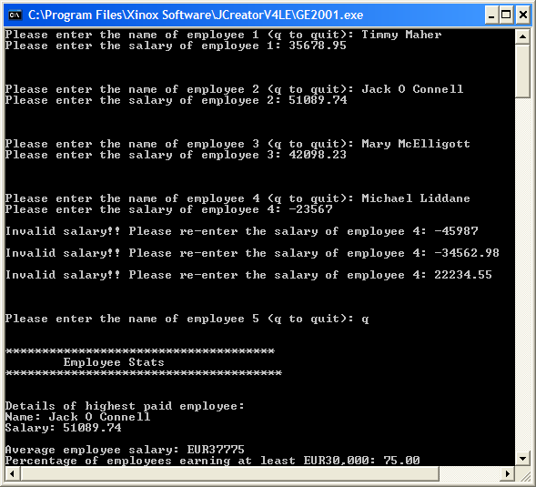

**Run 2 - The user is prompted for an employee name, they enter “q” immediately and are issued with an appropriate message (the loop never gets entered in this case)**

